**Digit Recognition-AI project**

**Fan Liu**

I use two packages to train the model: H2o and Keras. The two accuracy I got from

H2o are both lower then Keras accuracy. Here is the table to show three accuracy from these two packages:

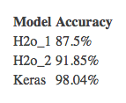

There two images in my code:

One is to plot the first 100 digit images

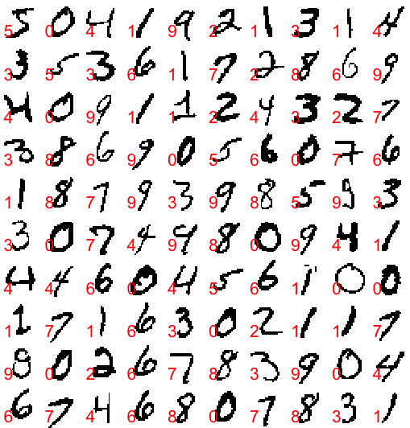

The other one is accuracy result from Keras model:

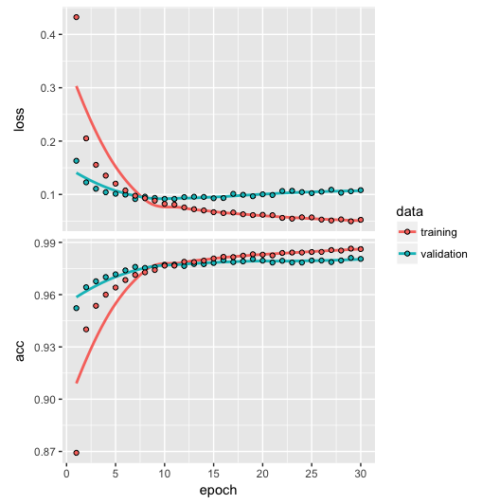

The details about the code please got to “lib” file.